Name: Lucas Jackson Mark _____________________/50

## Brief introduction __/3

The audio management system will handle all sound effects and music in Obstacle Odyssey. Within the menu, button interactions will have sound effects and background music will play. Within a level, entity interactions (collisions, item pickup, etc.) will have sound effects, the terrain will play appropriate sounds (ocean waves), and background music will play.

## Use case diagram with scenario __14

### Use Case Diagrams

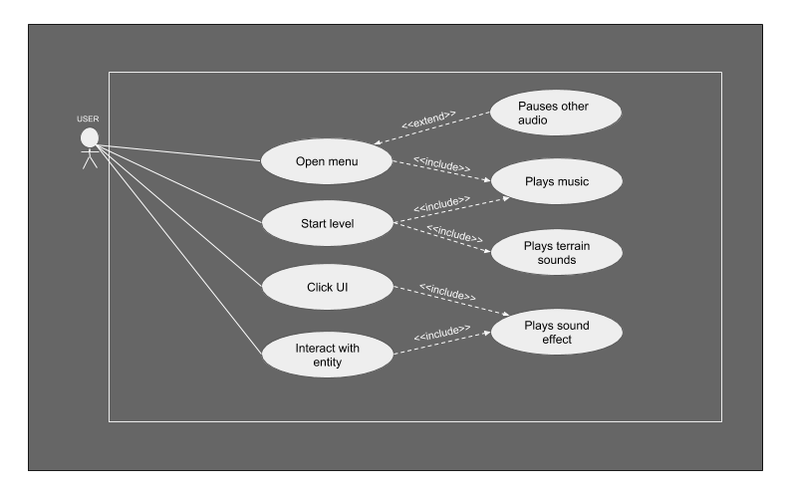

### Scenarios

**Name:** Play Sound

**Summary:** The player gets audio feedback based on game interactions.

**Actors:** Player of the game

**Preconditions:** The game has launched.

**Basic sequence:**

**Step 1:** The player opens the menu and background music plays.

**Step 2:** The player clicks a UI option and a UI sound effect plays.

**Step 3:** The player starts a level and background music plays.

**Step 4:** The players starts a level and terrain sounds play.

**Step 5:** The player interacts with an entity and an entity sound effect plays.

**Exceptions:**

**Step 1:** The menu is opened while a song/effect is already playing. That audio is stopped until the menu closes.

**Post conditions:** The correct audio has played for the situation.

**Priority:** 3*

**ID:** P03

*The priorities are 1 = must have, 2 = essential, 3 = nice to have.

## Data Flow diagram(s) from Level 0 to process description for your feature _______14

### Data Flow Diagrams

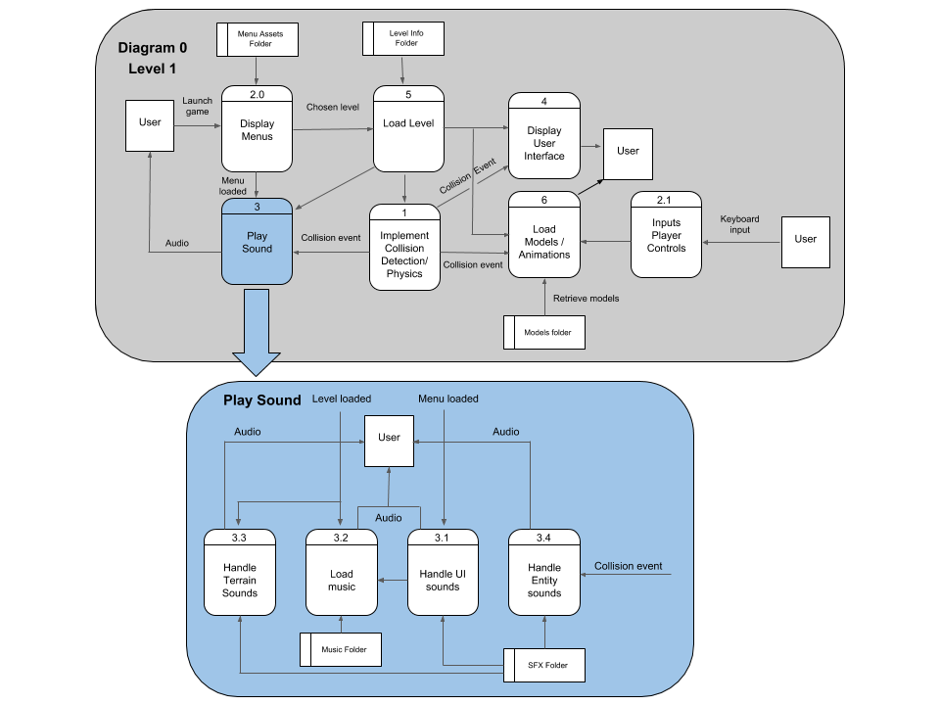

### Process Descriptions

* 1. **Handle UI sounds:**

If UI element is clicked, play appropriate UI sound effect

* 1. **Load music:**

If menu is open

Load menu music

While menu is open, play, and loop music file

Else if a level has loaded

Load level music

While level is focused, play and loop level music file

* 1. **Handle terrain sounds:**

If level is loaded

Load terrain sounds specific to level

If player is near audible terrain

Play appropriate terrain sound effect

Loop any persistent sounds (ocean waves)

* 1. **Handle Entity sounds:**

If level is loaded

Load entity sounds specific to level

If entity constantly produces sound

Play and loop sound effect when player is near entity

If player interacts/collides with entity

Play entity sound effect

## Acceptance Tests ________9

Call sounds by playing through folder of sound effects and folder of music, outputting a flag when the audio file starts and ends. Do this 10 times for each audio file. The output file should have 2 flags for every file played if they played through successfully. Any file that does not consistently have 2 flags should be inspected for error.

## Timeline _________/10

### Work items

|  |  |  |
| --- | --- | --- |
| Task | Duration (Hrs) | Predecessor Task(s) |
| 1. Background Music | 5 | - |
| 2. UI Sounds | 2 | 1 |
| 3. Entity Effects | 3 | 1 |
| 4. Terrain Effects | 2 | 1 |
| 5. Testing | 3 | 2,3,4 |

### Pert diagram

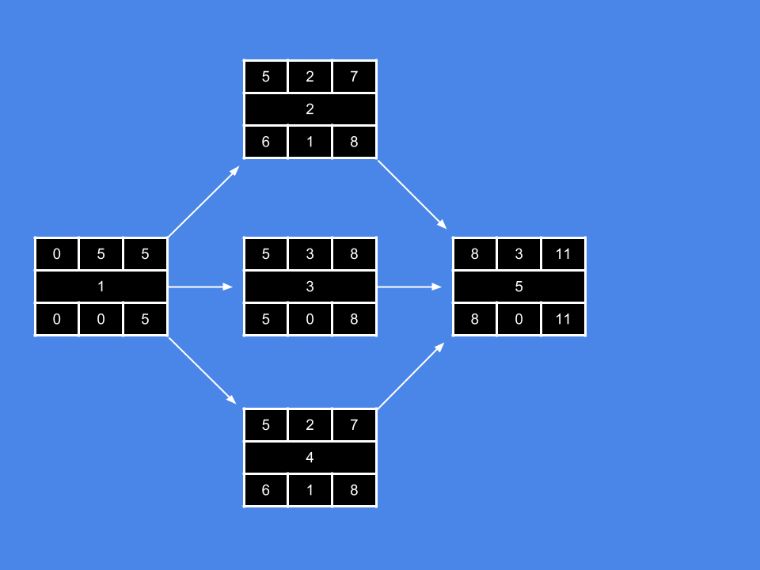

### Gantt timeline

|  |  |  |  |  |  |  |  |  |  |  |  |  |  |  |  |
| --- | --- | --- | --- | --- | --- | --- | --- | --- | --- | --- | --- | --- | --- | --- | --- |
| Background Music |  |  |  |  |  |  |  |  |  |  |  |  |  |  |  |
| UI Sounds |  |  |  |  |  |  |  |  |  |  |  |  |  |  |  |
| Entity Effects |  |  |  |  |  |  |  |  |  |  |  |  |  |  |  |
| Terrain Effects |  |  |  |  |  |  |  |  |  |  |  |  |  |  |  |
| Testing |  |  |  |  |  |  |  |  |  |  |  |  |  |  |  |
|  | 1 | 2 | 3 | 4 | 5 | 6 | 7 | 8 | 9 | 10 | 11 | 12 | 13 | 14 | 15 |